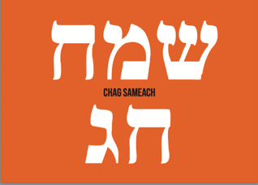

ROSH HASHANA CARD ORDER FORM 2025

To place your order, return this form and your list of recipients with complete addresses. Please place your order by Monday, September 8th, 2025, to ensure that your cards reach their intended recipients in time for Rosh Hashana
Options for purchasing print cards:
- Call 647-533-4497
- E-mail your order to Canada@israelrescue.org
- Click here to send your e-cards cards
STEP 1 – ENTER YOUR PRINT CARD ORDER INFORMATION | TOTAL
To order 10 cards or less, the price is $10 per card. Enter the number of cards you would like to purchase and calculate your total. $10.00 x = | $
To order 11 cards or more, the price is $8 per card. Enter the number of cards you would like to purchase and calculate your total. $8.00 x = | $
To order a package of 12 blank cards with envelopes to send on your own is $100. Enter the number of packages you would like to purchase and calculate your total. $100.00 x = | $
S STEP 2 – ENTER YOUR ADDRESS AND PAYMENT INFORMATION
Note: the Canada Customs and Revenue Agency requires that donation receipts bear the name and address of the actual donor. If this donation is being made on behalf of a group or company, please enter the group or company name in the last name field
Title: First Name: Last Name:
Address:
City: Province: Postal Code:
Phone: Email:
Visa/MasterCard/Amex. _ _ _ _ _ _ _ _ _ _ _ _ _ _ _ _ _ Expiry: _ _/_ _
Signature: Date:

